**ACKNOWLEDGEMENT**

The success and final outcome of this project required a lot of guidance and assistance from many people and we were extremely fortunate to have got this all along the completion of our project work. Whatever we have done is only due to such guidance and assistance and we would not forget to thank them.

We owe our profound gratitude to our internal project guide Mr. R.A.Patil Sir who took keen interest in our project and helped us to update our course of action with his insights. It was only with the help of his valuable feedbacks that we were able to develop our system efficiently.

We would also like to thank him for imparting us with a wonderful opportunity to let us get through with the project and test our skills while doing so. Moreover we would not forget to thank our Principal Sir Dr. V.B. Gaikwad to allow us to avail the services of Computer Science Department.

We are thankful to and fortunate enough to get encouragement, support and guidance from all teaching staff of department of Computer Science which helped us in successfully completing the graduation , post graduation and a project work. Also, we would like to extend our sincere regard to all the non-teaching staff of department for their timely support.

**INDEX**

|  |  |
| --- | --- |
| SR.NO | CONTENTS |
| 1. | INTRODUCTION |
| 2. | PROBLEM DEFINITION |
| 3. | SYSTEM REQUIREMENTS |
| 4. | EXISTING SYSTEM VS PROPOSED SYSTEM |
| 5. | SCOPE OF OUR PROJECT |
| 6. | DATA DICTIONARY |
| 7. | E-R DIAGRAM |
| 8. | UML DIAGRAMS |
| 9. | SAMPLE I/O SCREENS |
| 10 | CIRCUIT CONFIGURATION PICTURES |
| 11. | CONCLUSION |
| 12. | BIBLIOGRAPHY |

**INTRODUCTION**

The concept of a Smart City highlights the need to enhance quality, interconnection and performance of various urban services with the use of information and communication technologies (ICT). Smart City technologies promote cloud-based and Internet of Things (IoT) based services in which real-world user interfaces use smart phones, sensors and RFIDs. Cloud computing and IoT are presently two most important ICT models that are shaping the next generation of computing. Both concepts have major impact on how we build and deploy smart applications/solutions for smart cities. Cloud computing represents the delivery of hardware and software resources on demand over the Internet-as-a-service. On the other hand, IoT concept envisions a new generation of devices (sensors, both virtual and physical) that are connected to the Internet and provide different services for value-added applications.

The “Smart City” Project models the idea of modern Smart Cities and implements some of its major characteristics. Our System has many functions but the ‘Soil Moisture Content Monitoring and Automatic Water Supply’ is outstanding. Other notable services include Parking Management and Smart Street Light System. Basically system will be accessed by two entities. They are

**ADMIN :**

The admin will basically monitor all the activities or events that occur in our proposed system and if there is an exception, the admin will take charge and notify the government organization to respond to that specific event.

**USER :**

The user will be able to make his/her life more convenient with the help of the services provided by our Smart City App. The user can view information and use services to find parking locations and park their cars more conveniently and efficiently.

**PROBLEM DEFINITION :-**

Most modern cities on the planet are built on rich infrastructure and robust management systems regulated by government bodies but what they lack most is synchronization. Various systems in city work independently and interact periodically for the proper functioning of the city. There are a lot of facilities provided in modern city to their citizens but they are not easily accessed because of lack of an intelligent support system. For instance, conventional street lights control system keeps the lights on even when the roads are vacant during night, thereby not doing much on the energy saving front!

This is where smart city comes into the picture!

Basically a smart city is an urban area where there are different types of electronic data collection sensors to supply information. Smart cities use information and communication technologies (ICT) to be more intelligent and efficient in the use of resources, resulting in cost and energy savings, improved service delivery and quality of life, and reduced environmental footprint, all supporting innovation and the low carbon economy.

Everything is connected in a smart city right from a single electronic device to buildings, cars, lampposts, trash cans and much more… Smart cities are more eco-friendly than regular cities as they implement IOT systems to design energy-efficient policies which entails that energy is only produced from renewable resources and wastage of energy is avoided by supervision through smart systems in IOT based smart cities. Lack of technological aid in regular cities deprives the government and administrations to formulate an optimal budget plan. While this is not the case in smart cities since it is equipped with intelligent systems that can help to optimize city’s budget plan. Enhanced security systems can be achieved through smart sensors which can detect any abnormal activity in a specific area and alert security agencies of the same. Systems like face recognition and object detection along with CCTV surveillance can help us to achieve advanced security.

**SYSTEM REQUIREMENTS :-**

**HARDWARE SPECIFICATIONS :**

1. Intel Core Processor (i3, i5, i7)
2. RAM (Minimum 2GB)
3. Hard Disk (Minimum 50 GB)
4. Wemos D1 R1, Arduino
5. LED’s
6. Breadboard and Wires
7. Sensors :

* Ultrasonic
* Pollution Detector
* Humidity / Temperature
* Soil
* Laser
* LDR

1. Motors :

* Servo
* Water Pump

**SOFTWARE SPECIFICATIONS :-**

1. OS : Linux / Android / Windows
2. Environment : Android Studio / Sublime / Arduino
3. Languages : Java / PHP / Arduino
4. Database : MySQLi
5. Firebase Cloud Messaging

**EXISTING SYSTEM VS PROPOSED SYSTEM :-**

The Existing System can be viewed as a regular city, without any smart features. They have fairly poor traffic control and transportation system. Energy production and supply systems are executed loosely; the overall implementation is an expensive process. Moreover there are no concrete measures being undertaken to protect environment.

The Proposed System is an IOT based smart city system model. It includes various modules like Smart Traffic Management, Smart Street Lights, Smart Parking System and some other components of a smart city. Our Proposed System has following features

* A Smart Street Light system that switches on only when it senses a vehicle in its close proximity, thereby saving electrical energy.
* Smart Parking facility that can be easily located by the user. User can check for available parking slots.
* A Smart Irrigation system that checks the water content/moisture in soil and if the water content is critically low, it will provide water to the plants.
* We have implemented a pollution monitoring system that checks the air for infiltration and also notifies user if the level of carbon in air is beyond the permissible amount.
* A Smart Traffic Control system that enforces traffic rules and notifies the traffic authorities if someone violates the rules.

The Proposed System will help us to overcome the limitations of Existing system. It will also considerably increase efficiency of daily urban activities, improve quality of life, and provides digital connectivity. Our system will assist admin in decision making with regard to the services provided to the citizens/users.

**SCOPE OF OUR PROJECT**

Our System basically models an IOT based smart city. We have built a model that comprises of sensors, actuators and micro-controllers that are managed by software apps developed in Android, PHP and Arduino. We tried and accomplished to model some, not all aspects of a smart city such as the smart street light system that activates only when a vehicle is detected in its area. There is also Smart Parking and Traffic control units that will reduce the burden of Traffic Management and Parking Management quite significantly. Moreover we also have Pollution, Temperature and Humidity Monitoring System that will help the government to regulate their policies with respect to environment protection and public healthcare. We have also achieved to develop a smart irrigation facility keeping in mind the idea of conservation of resources wherein the sensors detect the soil moisture and supply water only when it is required.

However, there are some specific limitations to our system. We have opted out the security features of a smart city due to lack of financial and technical support. The Parking Location map in our system fails to indicate route, it only locates the parking region in an area.

Nevertheless, we believe that there is always scope for future enhancements. With adequate financial support and necessary tools we can go for more advanced features that will make our system robust and collectively more efficient.

**FEASIBILITY STUDY**

A feasibility study is conducted to evaluate that the proposed system is viable or not. It aims to exploit the strengths and weakness of the system and thus giving an idea whether the system will achieve its goal seamlessly.

Following are the three most important factors in the feasibility study of a proposed system.

1. **Technical Feasibility :**

This assessment is based on an outline design of system requirements, to determine whether the company has the technical expertise to handle completion of the project. It involves following points

* There exists necessary technology and infrastructure to develop and execute such a system.
* The Proposed system has a database that handles all the data generated during system’s transaction.
* Our system provides real time response and is not affected by the number of the users accessing the application.
* All the software and hardware components necessary for the execution of the application are easily available.

1. **Operational Feasibility :**

Operational feasibility is the measure of how well a proposed system solves the problems, and takes advantage of the opportunities identified during scope definition and how it satisfies the requirements identified in the requirements analysis phase of system development.

* The proposed system is practically / operationally feasible.
* It seamlessly fits in with the existing business environment and transcends the previously installed system in the problem domain.
* The proposed system also solves the problems enlisted in the problem definition section.
* It considerably reduces the workload and time of the admin who controls the proposed system.

1. **Economical Feasibility :**

This is one of the most important factors of the feasibility study. It is used to determine the financial viability of the proposed system. Here we assess does the objective benefits of the system outweigh the capital cost incurred in the design and development of the application? If Yes! The system is economically feasible.

Our proposed system has considered following points with respect to economic feasibility

* The cost of hardware and software components necessary for the development of the system was reasonable and affordable.
* Also the cost incurred in the deployment and maintenance of the system is also reasonable.
* The benefits of the system indeed outweigh the cost of system development.

**DATA DICTIONARY**

1. **ADMIN TABLE**

|  |  |  |  |
| --- | --- | --- | --- |
| **Field name** | **Data Type** | **Size** | **Constraint** |
| **Aid** | **Number** | **-** | **Primary Key** |
| **aname** | **Varchar** | **50** | **-** |
| **aemail** | **Varchar** | **50** | **-** |
| **apass** | **Varchar** | **50** | **-** |
| **aphone** | **Varchar** | **10** | **-** |

1. **USER TABLE**

|  |  |  |  |
| --- | --- | --- | --- |
| **Field name** | **Data Type** | **Size** | **Constraint** |
| **Uid** | **Number** | **-** | **Primary Key** |
| **uname** | **Varchar** | **50** | **-** |
| **uemail** | **Varchar** | **50** | **-** |
| **upass** | **Varchar** | **50** | **-** |
| **uphone** | **Varchar** | **10** | **-** |

1. **GAS SENSOR TABLE**

|  |  |  |  |
| --- | --- | --- | --- |
| **Field name** | **Data Type** | **Size** | **Constraint** |
| **gid** | **Number** | **-** | **Primary Key** |
| **gdata** | **Number** | **-** | **-** |
| **garea** | **Varchar** | **50** | **-** |
| **gtime** | **Time/Date** | **-** | **-** |

1. **PARKING TABLE**

|  |  |  |  |
| --- | --- | --- | --- |
| **Field name** | **Data Type** | **Size** | **Constraint** |
| **pid** | **Number** | **-** | **Primary Key** |
| **pstatus** | **Boolean** | **-** | **-** |
| **parea** | **Varchar** | **50** | **-** |

1. **NOPARKING TABLE**

|  |  |  |  |
| --- | --- | --- | --- |
| **Field name** | **Data Type** | **Size** | **Constraint** |
| **npid** | **Number** | **-** | **Primary Key** |
| **npstatus** | **Boolean** | **-** | **-** |
| **nparea** | **Varchar** | **50** | **-** |
| **npsensorno** | **Number** | **-** | **-** |

1. **SOIL MOISTURE CONTENT TABLE**

|  |  |  |  |
| --- | --- | --- | --- |
| **Field name** | **Data Type** | **Size** | **Constraint** |
| **sid** | **Number** | **-** | **Primary Key** |
| **sdata** | **Varchar** | **50** | **-** |
| **sarea** | **Varchar** | **50** | **-** |
| **stno** | **Number** | **-** | **-** |
| **sdate** | **Time/Date** | **-** | **-** |

1. **TEMPERATURE / HUMIDITY TABLE**

|  |  |  |  |
| --- | --- | --- | --- |
| **Field name** | **Data Type** | **Size** | **Constraint** |
| **thid** | **Number** | **-** | **Primary Key** |
| **temp** | **Varchar** | **-** | **-** |
| **humidity** | **Varchar** | **-** | **-** |
| **tharea** | **Varchar** | **50** | **-** |
| **thtime** | **Time/Date** | **-** | **-** |

**E R DIAGRAM**

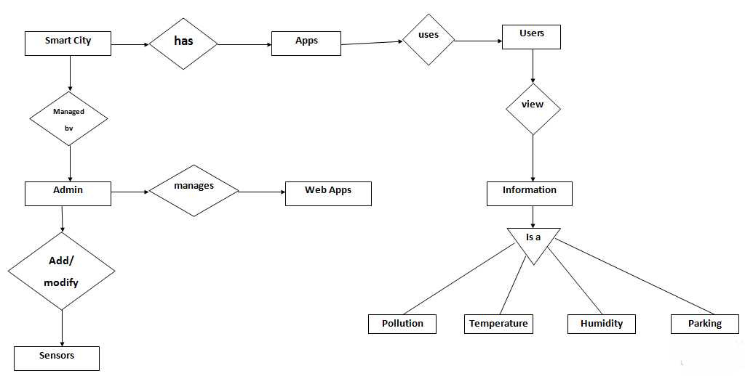

**UML DIAGRAMS**

1. **CLASS DIAGRAM**

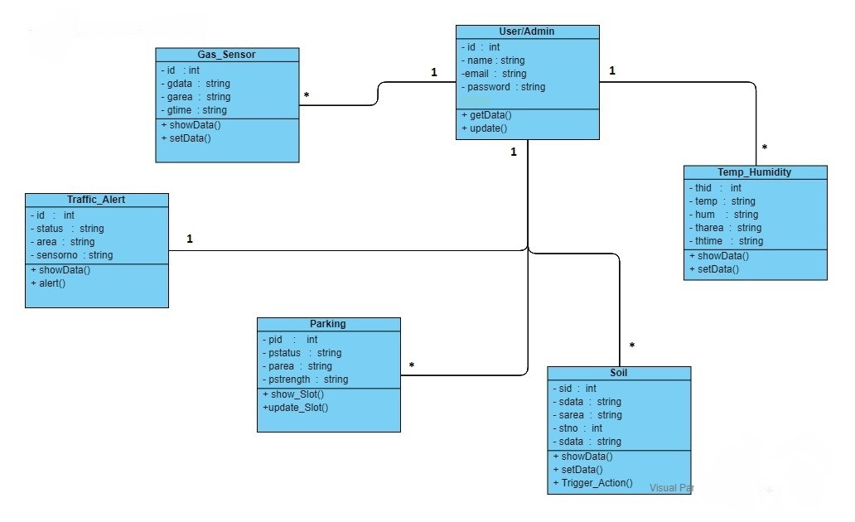

1. **USE CASE**

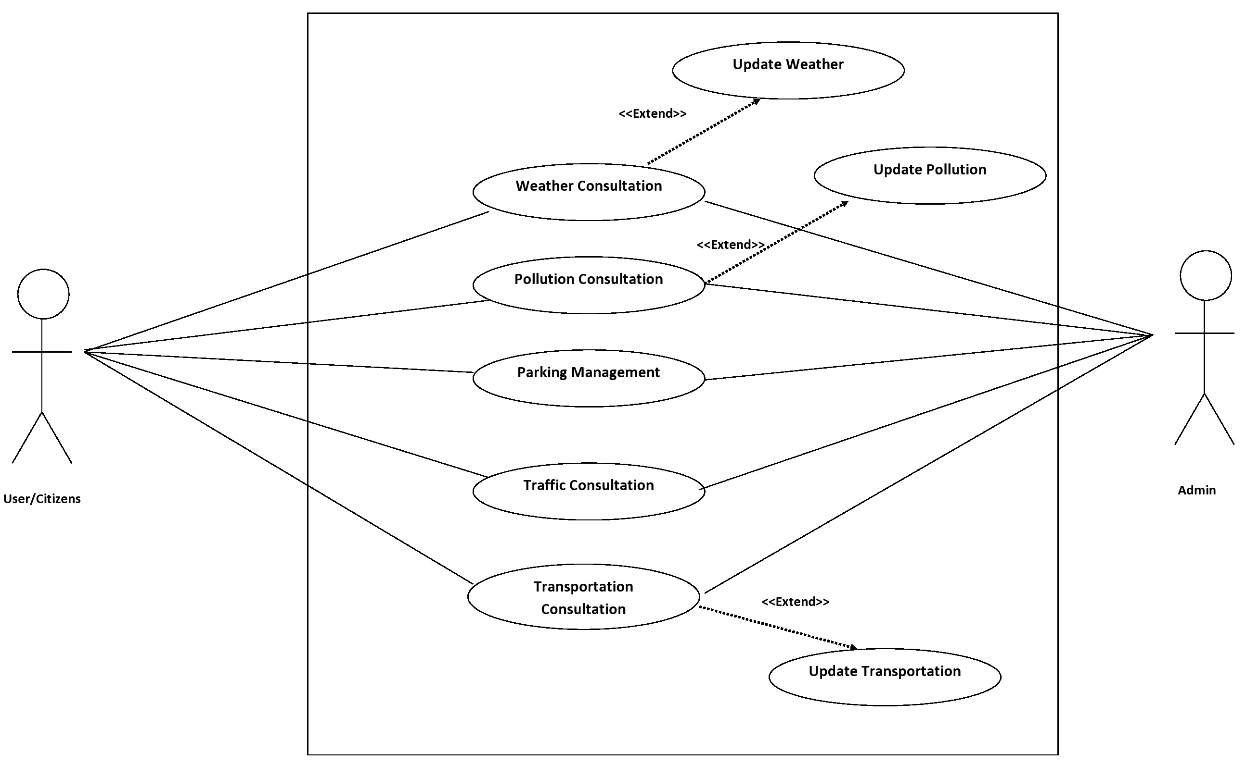

1. **ACTIVITY DIAGRAM (USER)**

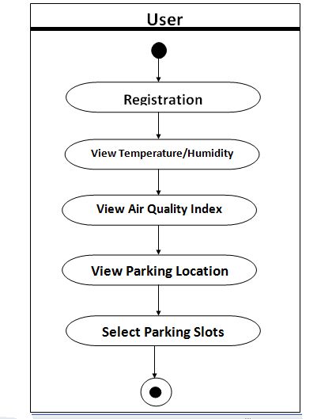

**ACTIVITY DIAGRAM (ADMIN)**

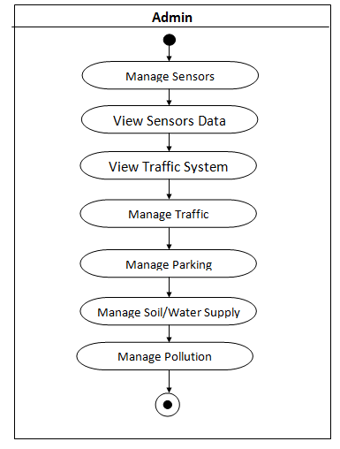

1. **SEQUENCE DIAGRAM (USER)**

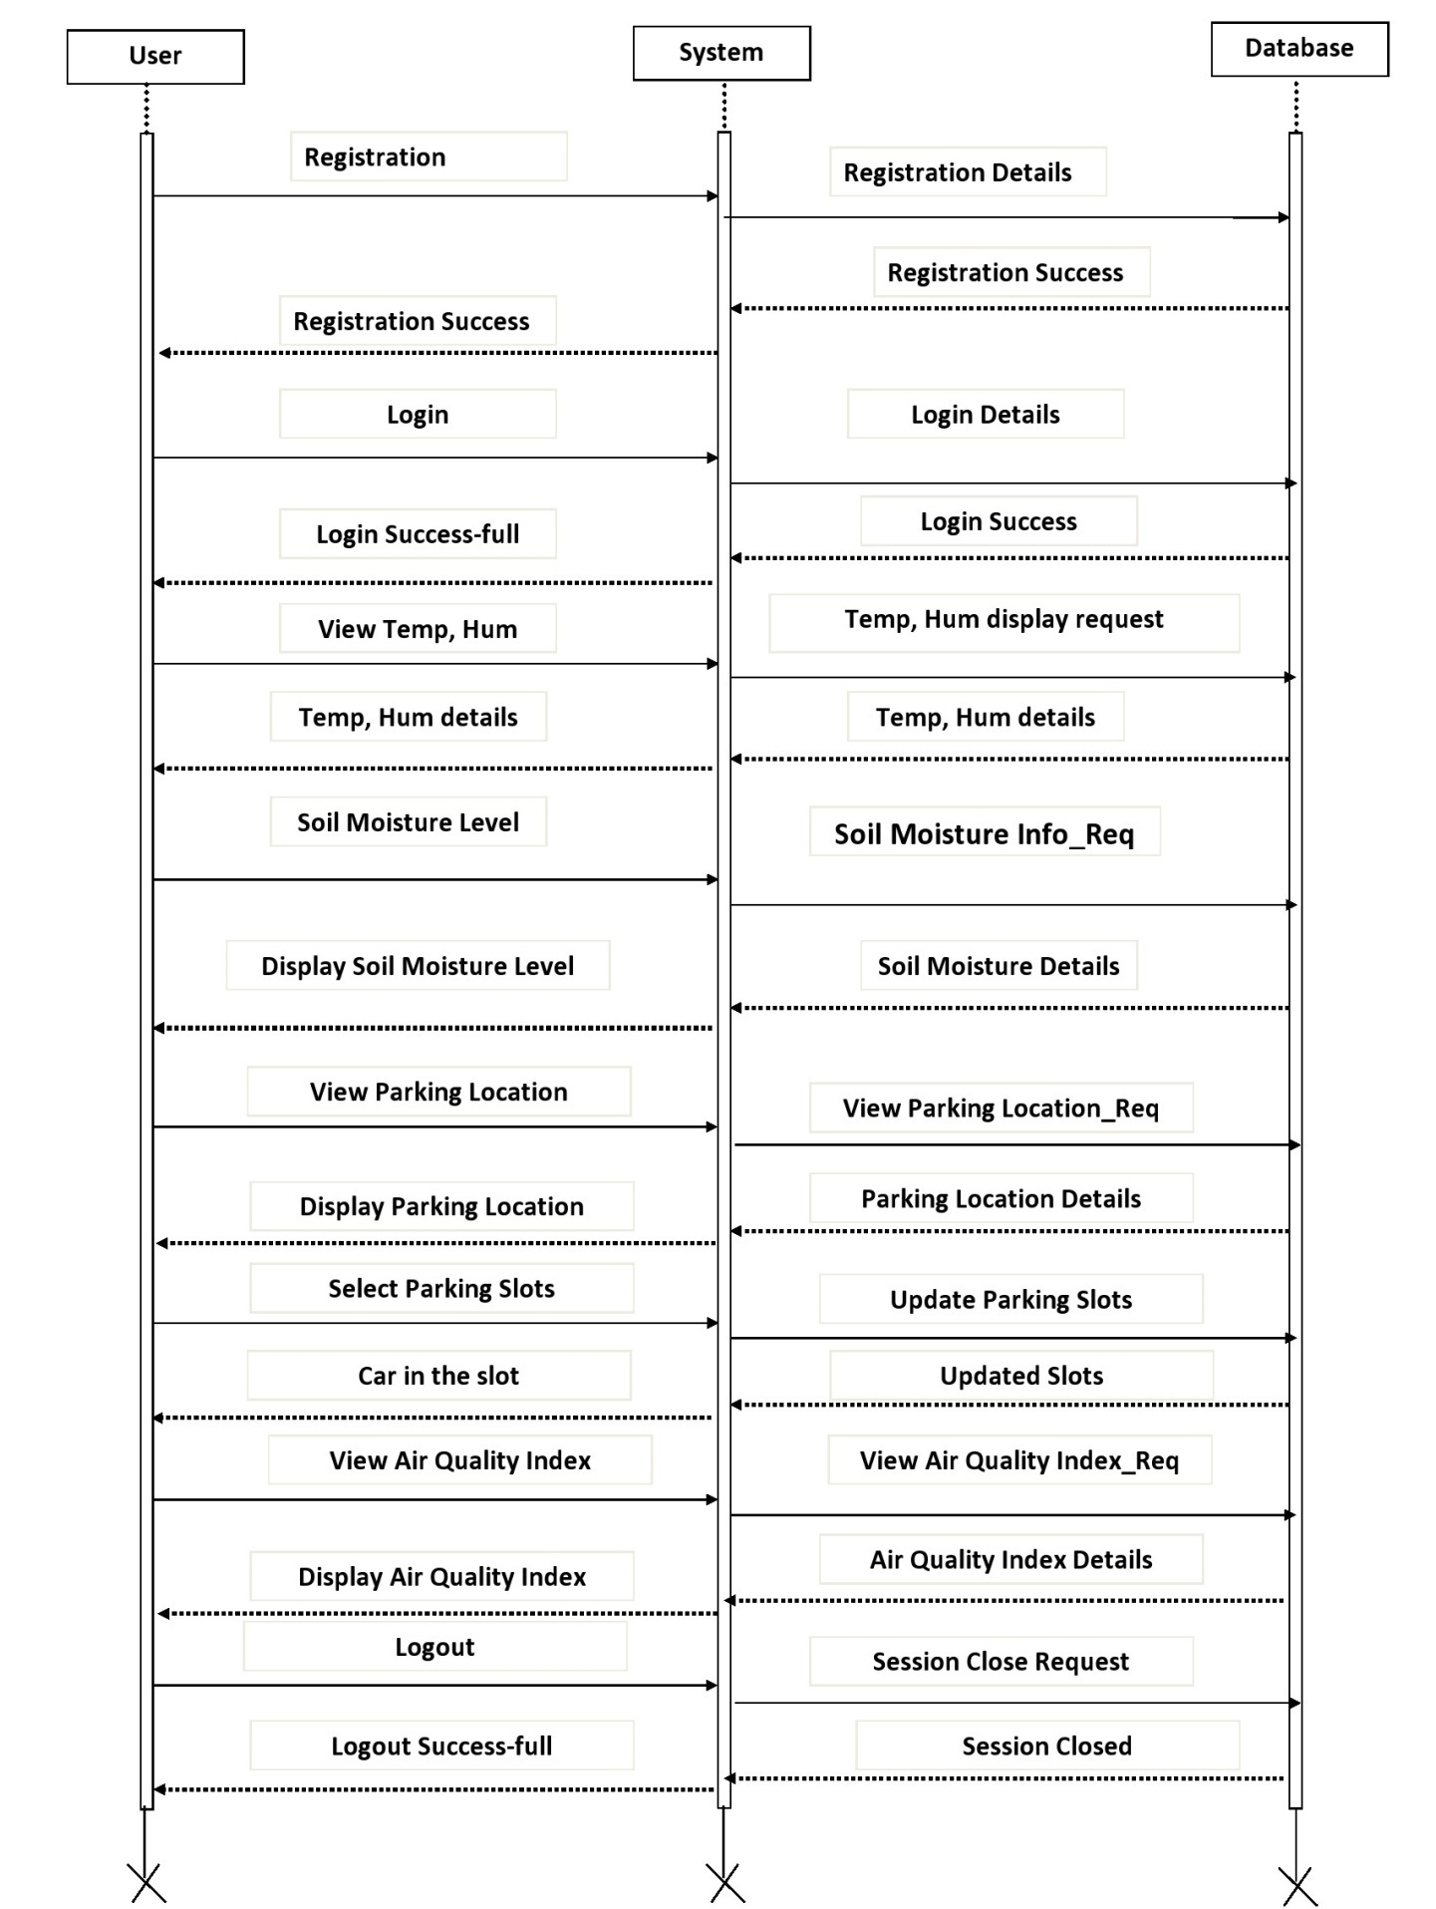

**SEQUENCE DIAGRAM (ADMIN)**

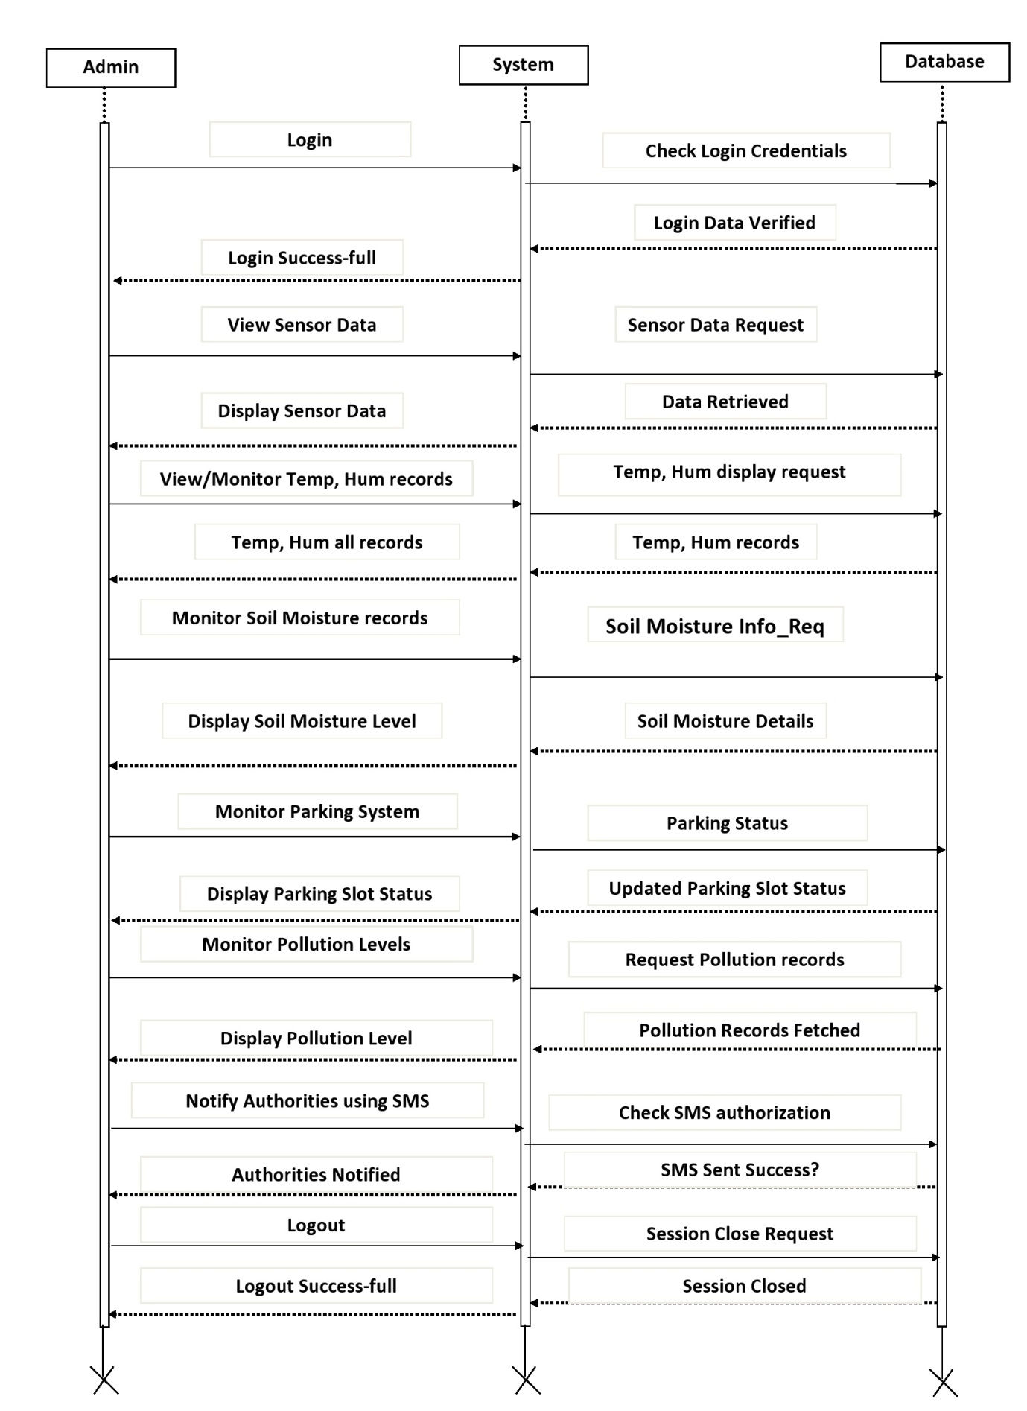

1. **DEPLOYMENT DIAGRAM**

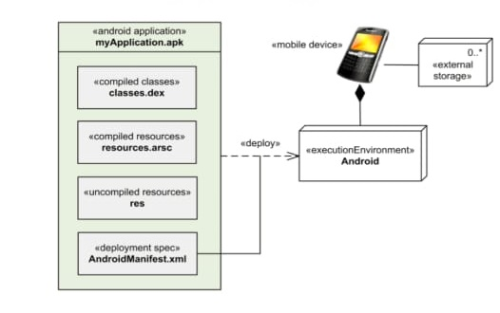

1. **COMPONENT DIAGRAM**

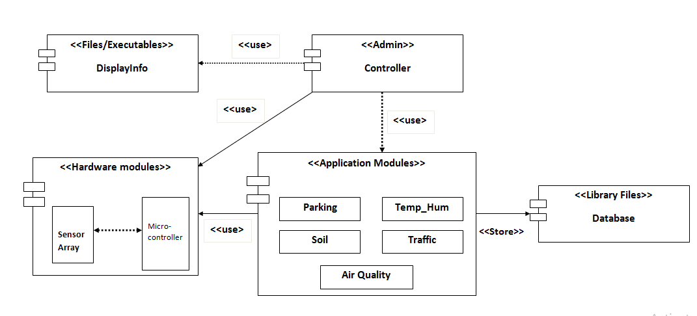

**SAMPLE I/O SCREENS.**

1. **Home Page.**

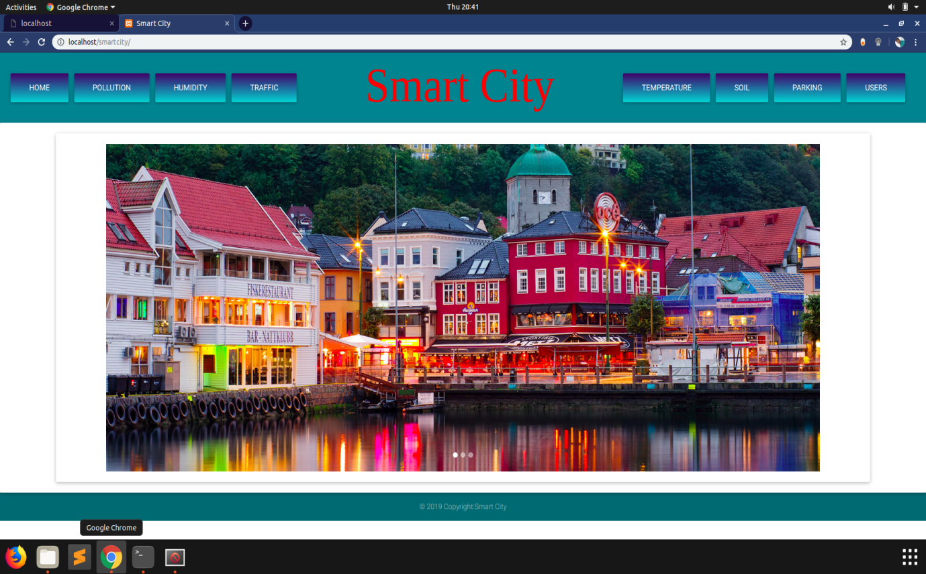

1. **Admin Control : Air Quality Check**

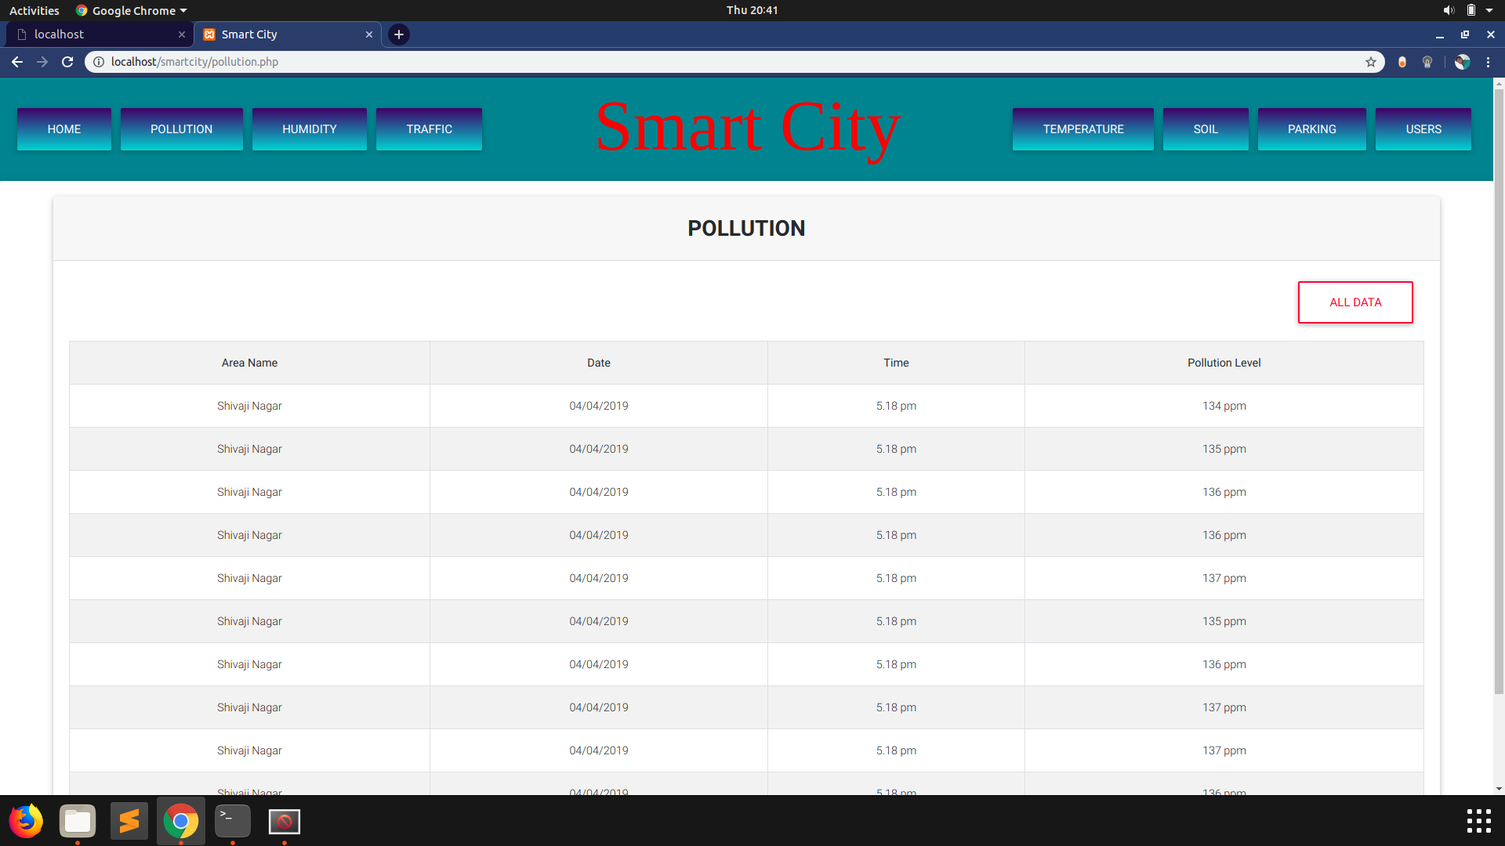

1. **Traffic Management**

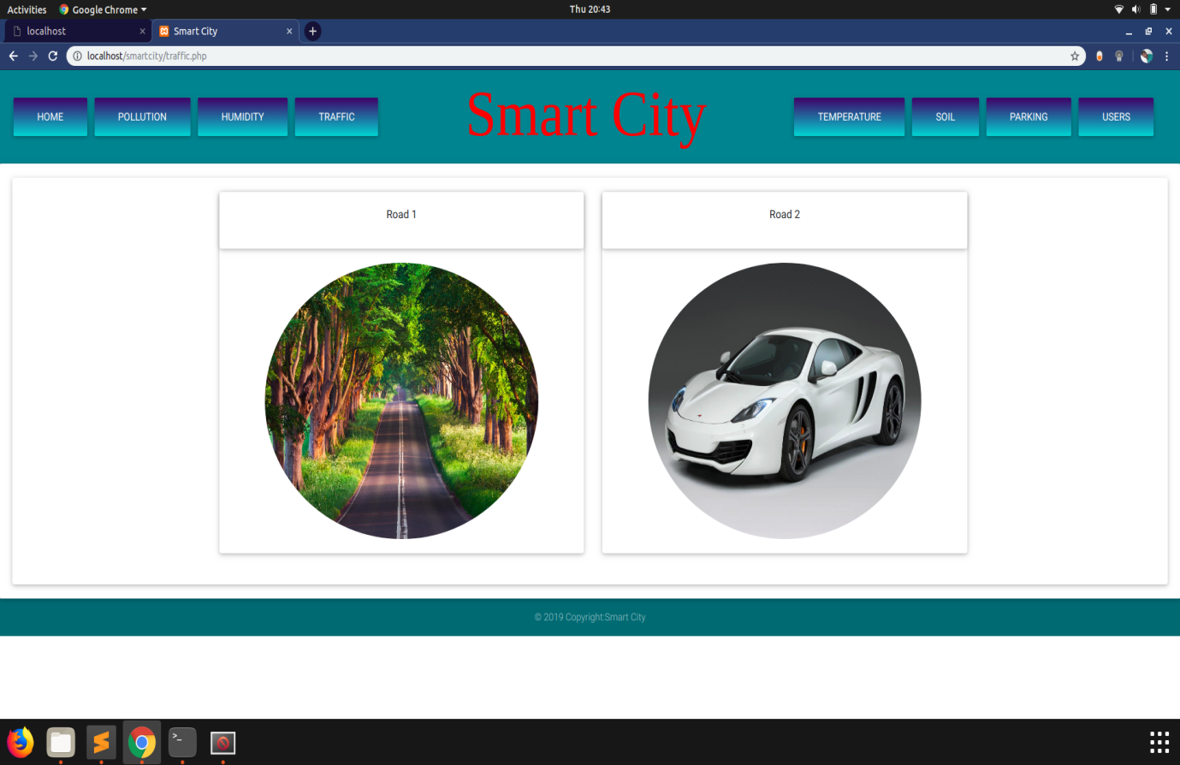

1. **Humidity Monitoring**

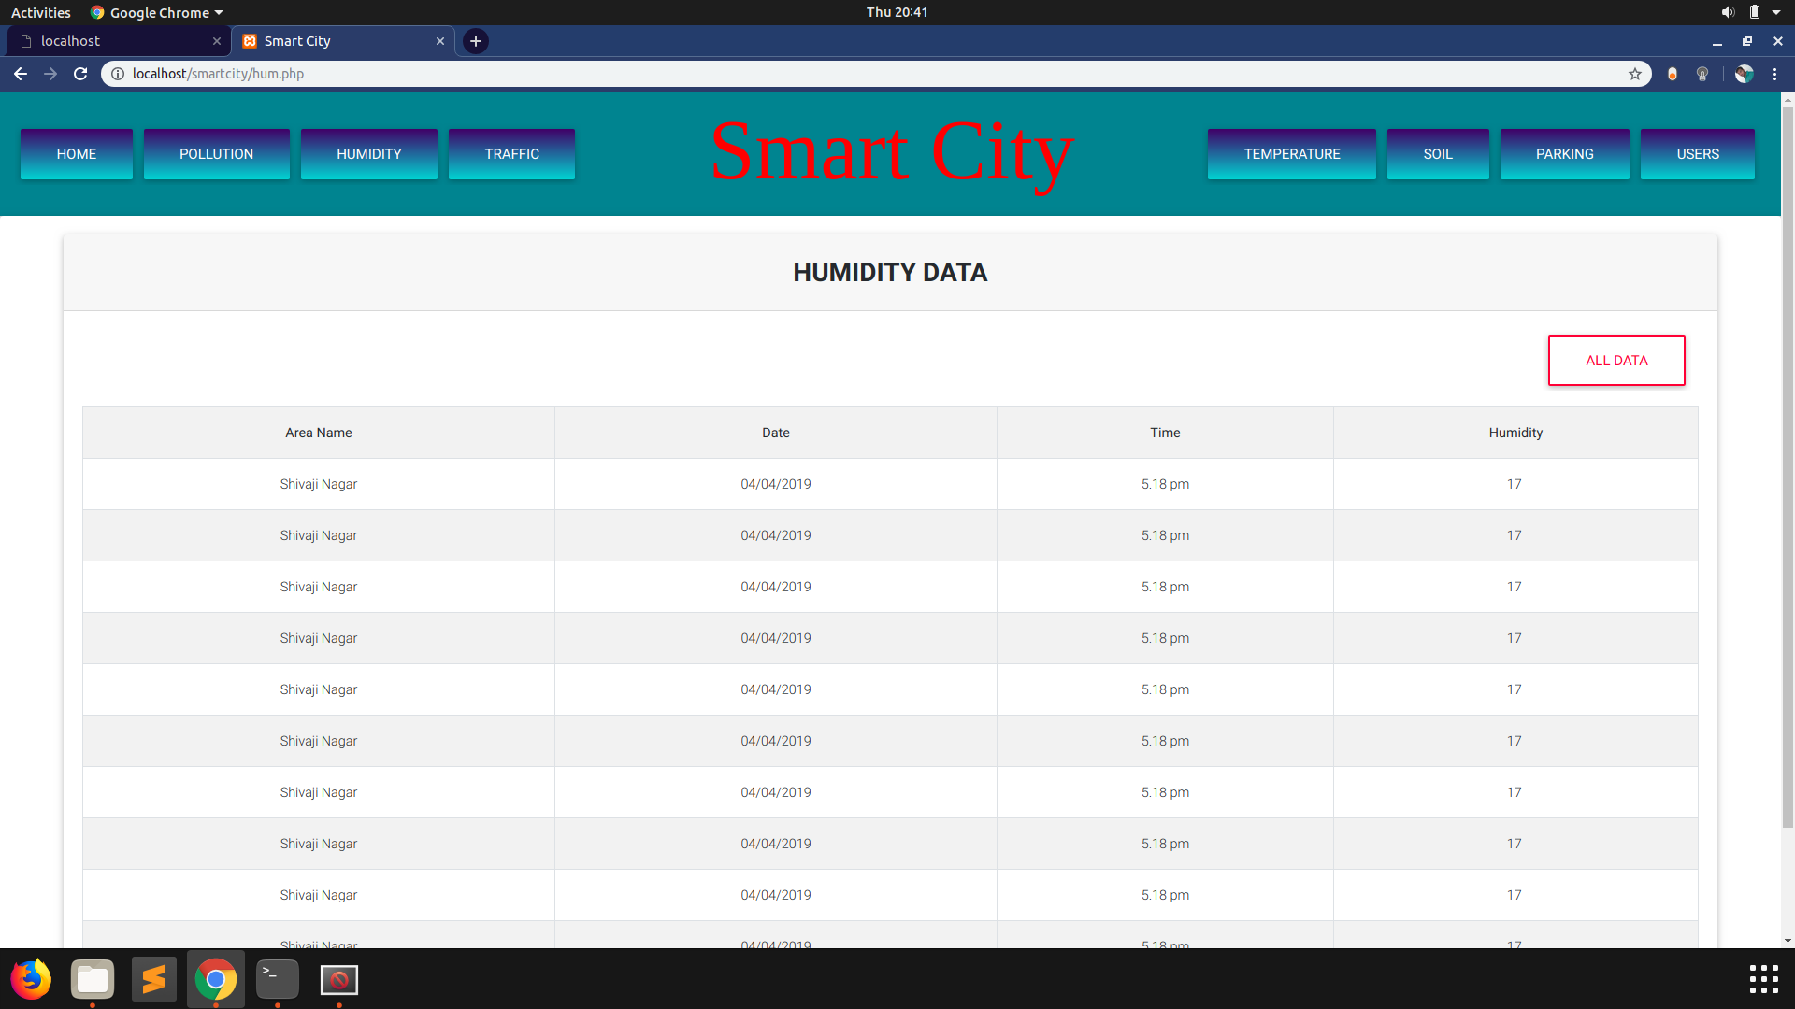

1. **Temperature Monitoring**

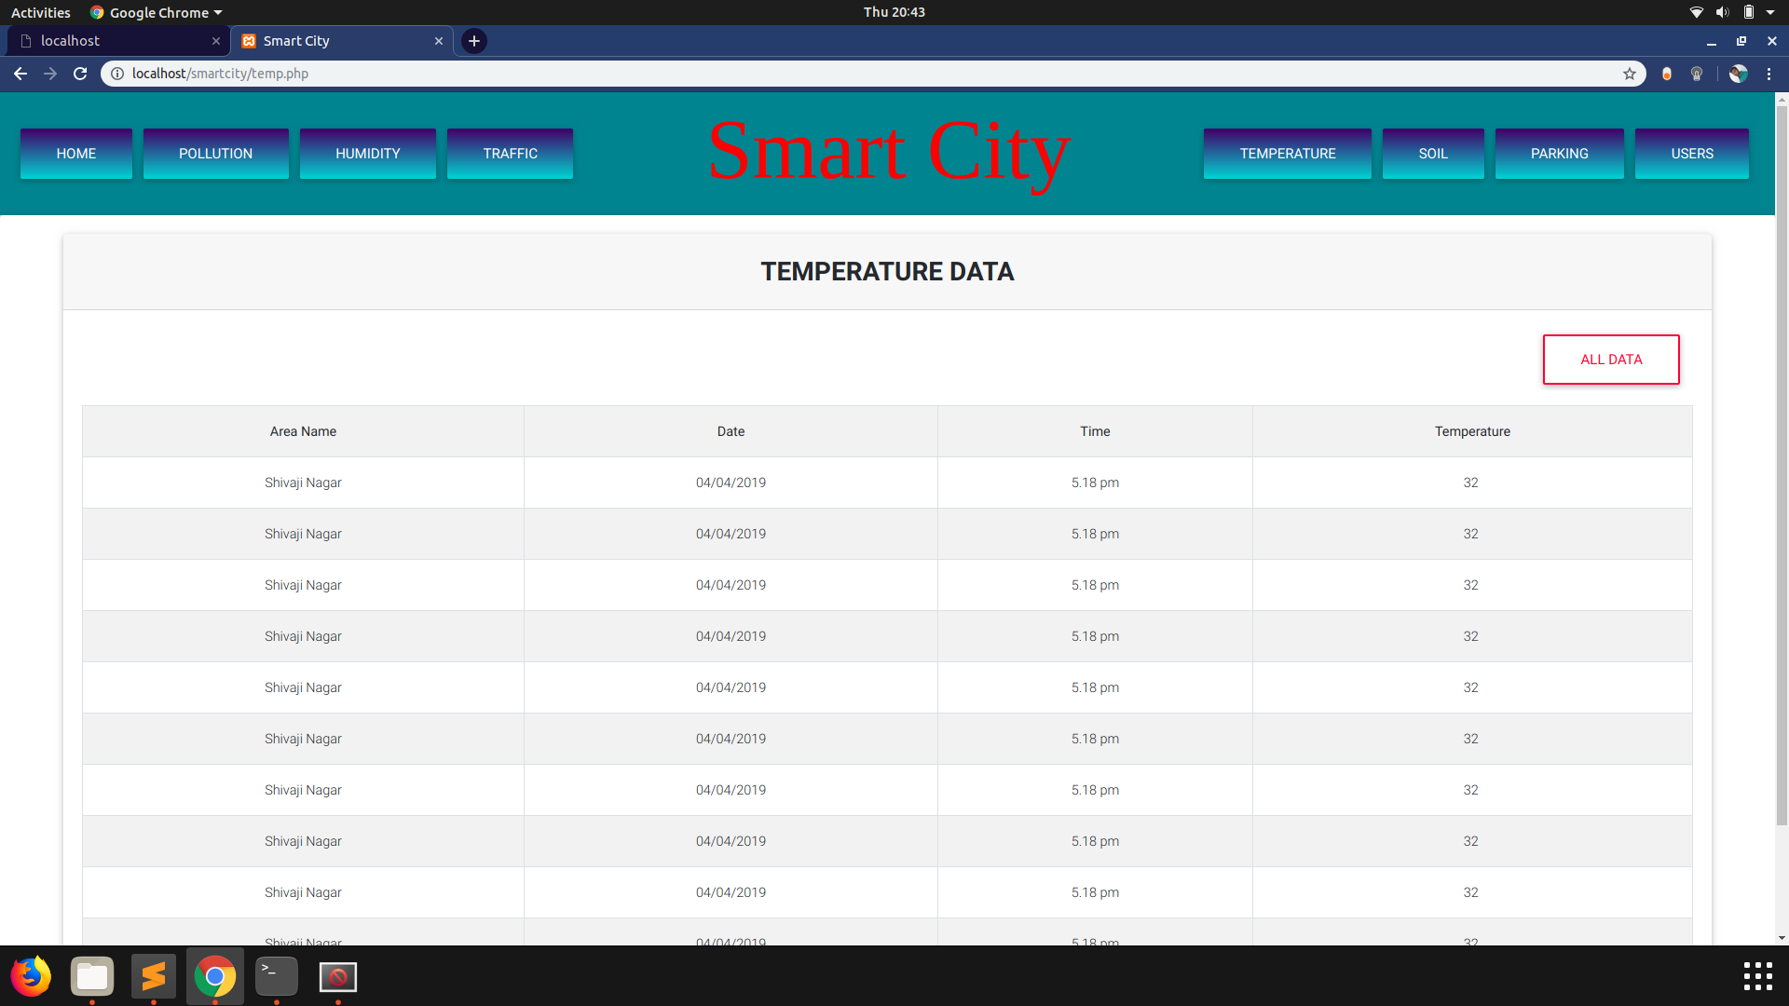

1. **Soil Moisture Content Monitoring**

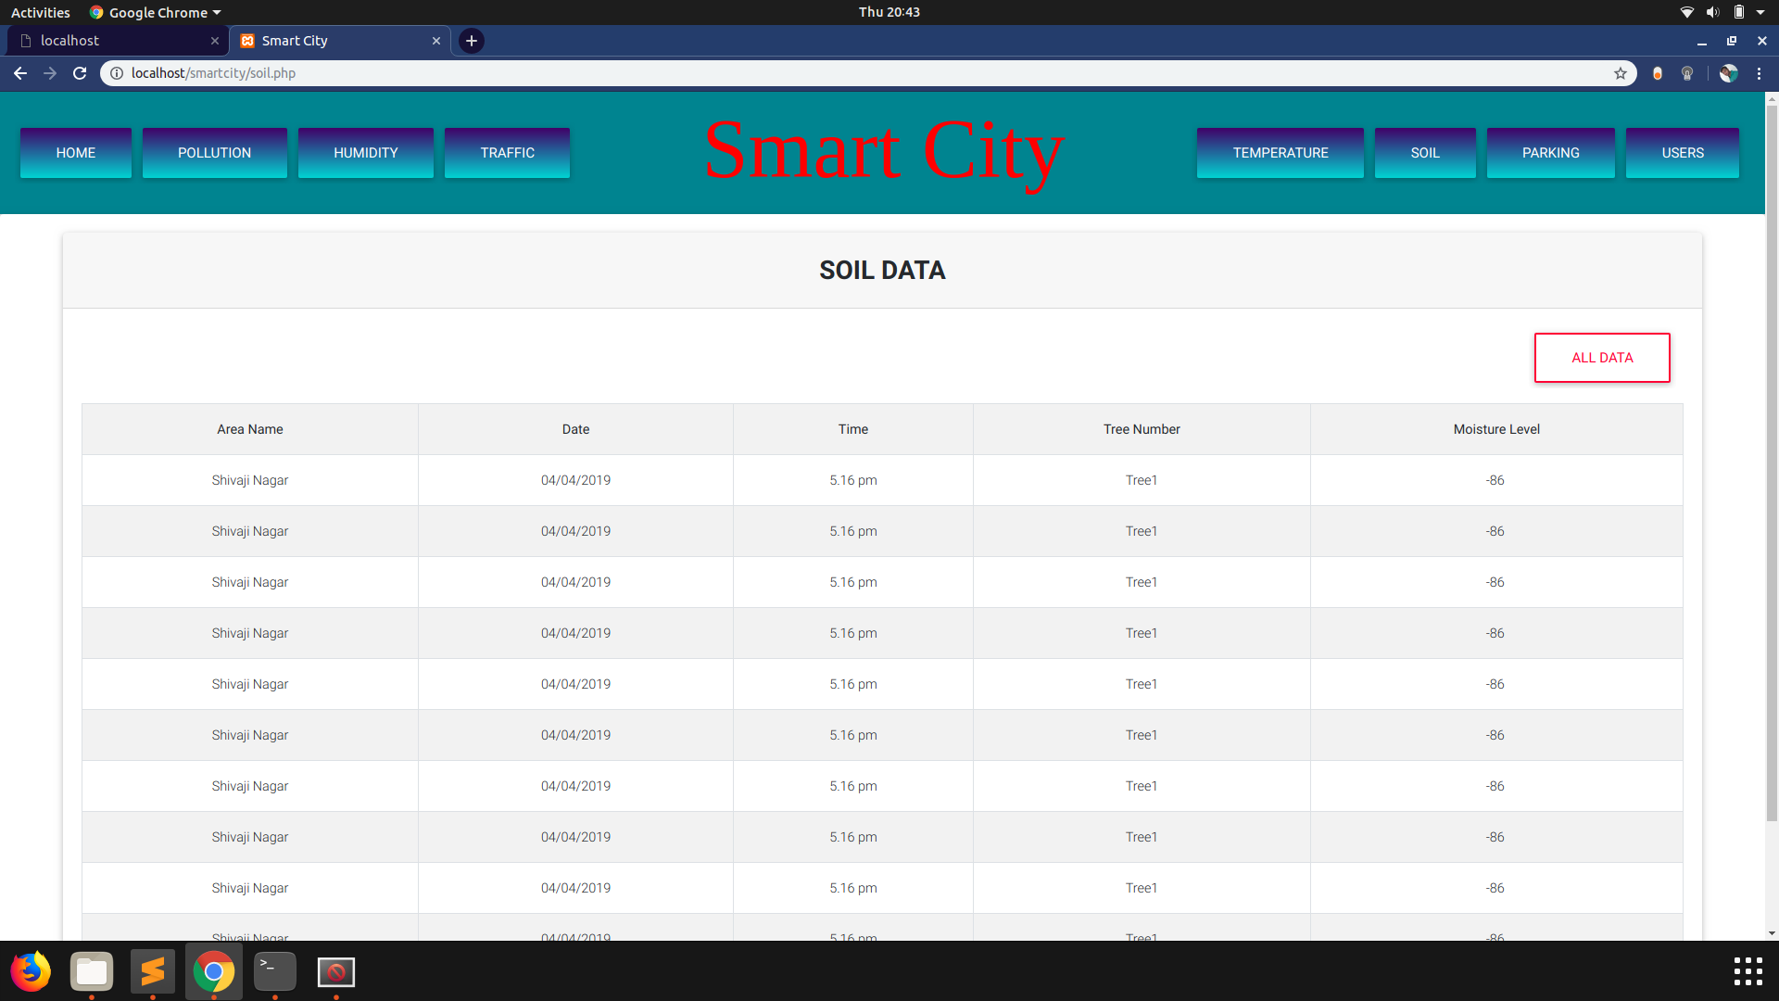

1. **Parking Slots Status**

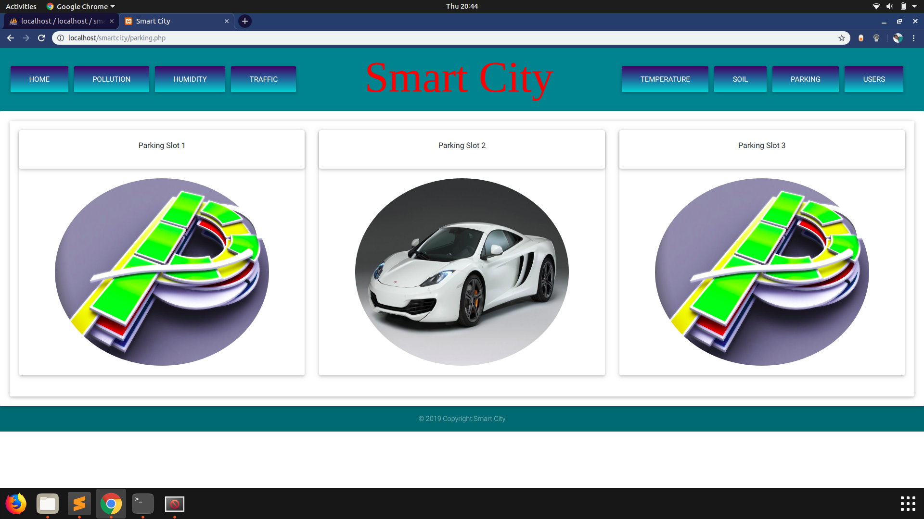

1. **User’s Data**

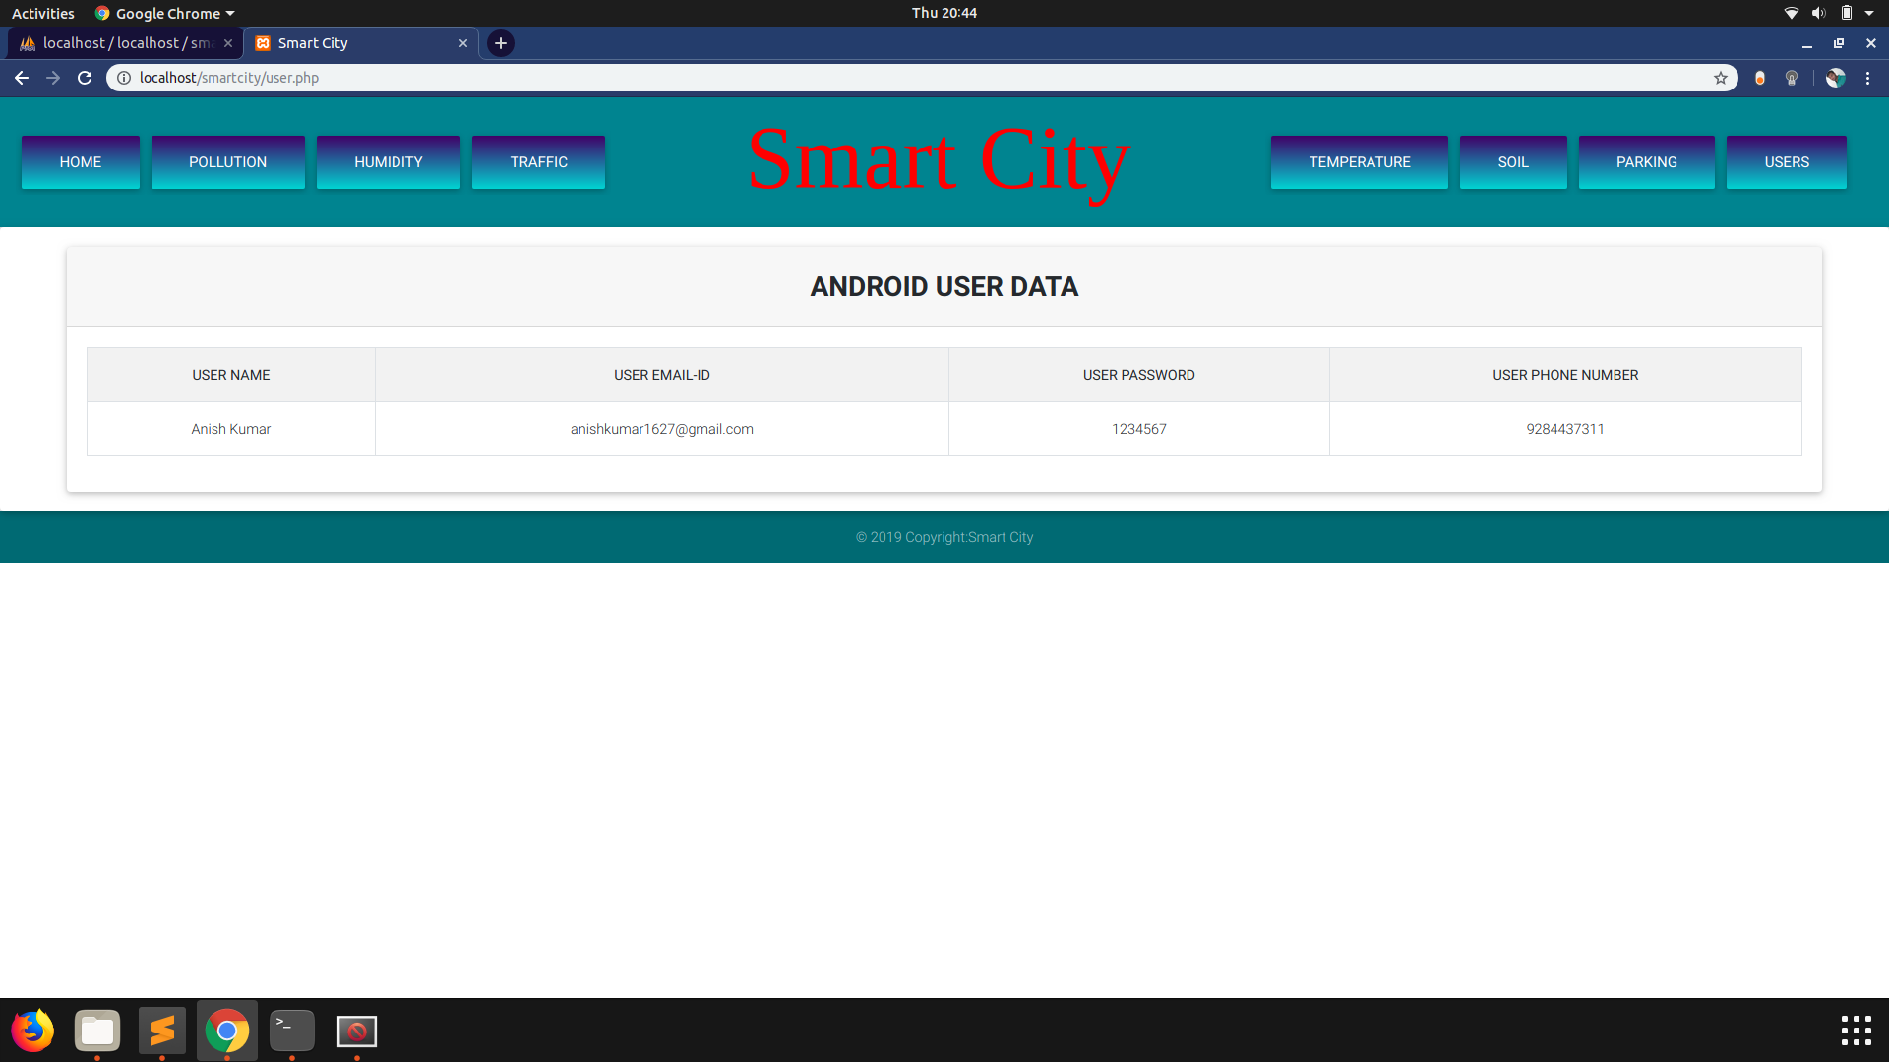

1. **Registration/Login Controls**

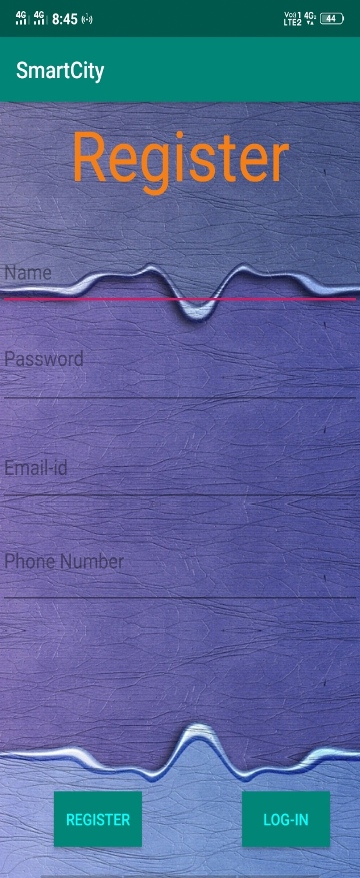 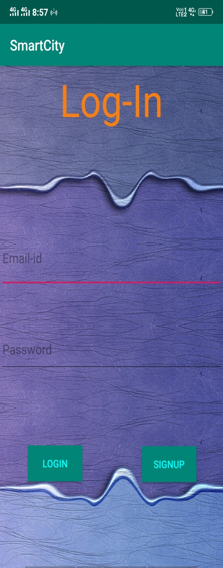

1. **User View Controls : Check for available parking location and slots, temperature, humidity and air quality index.**

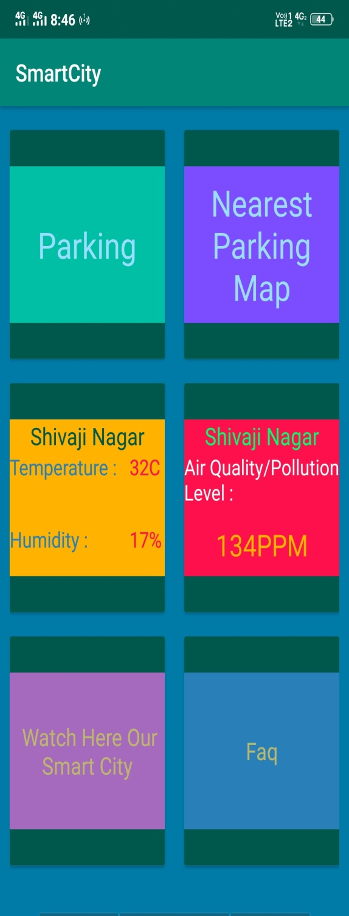 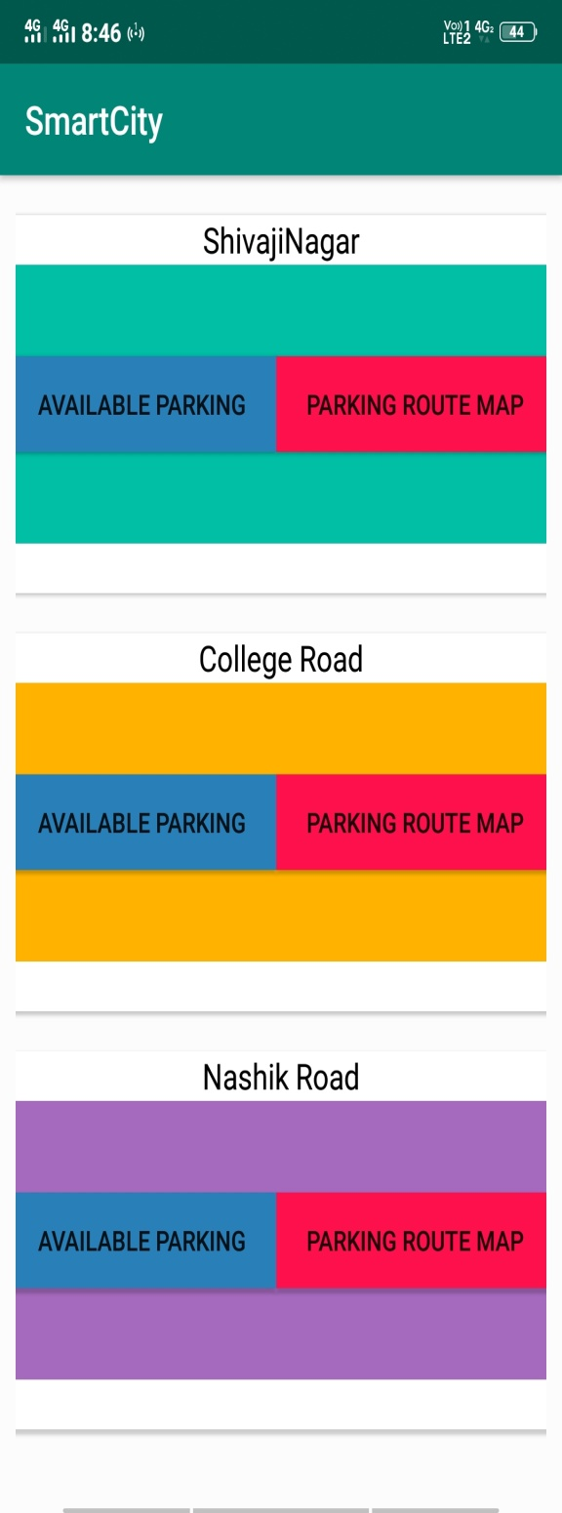

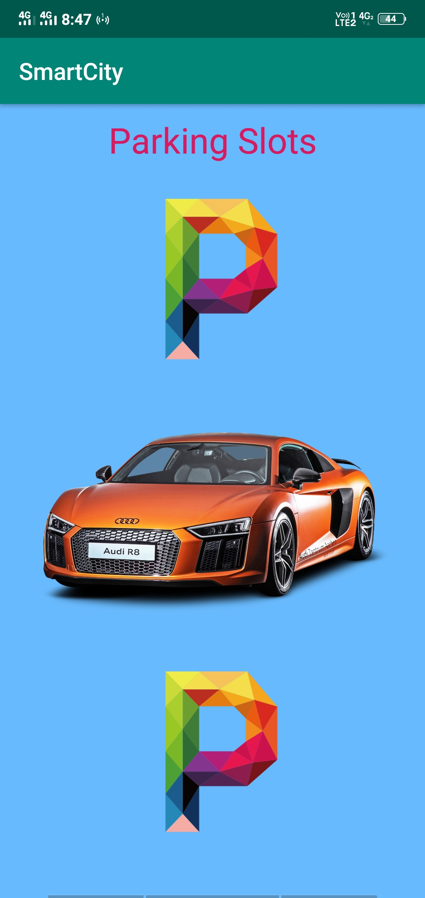

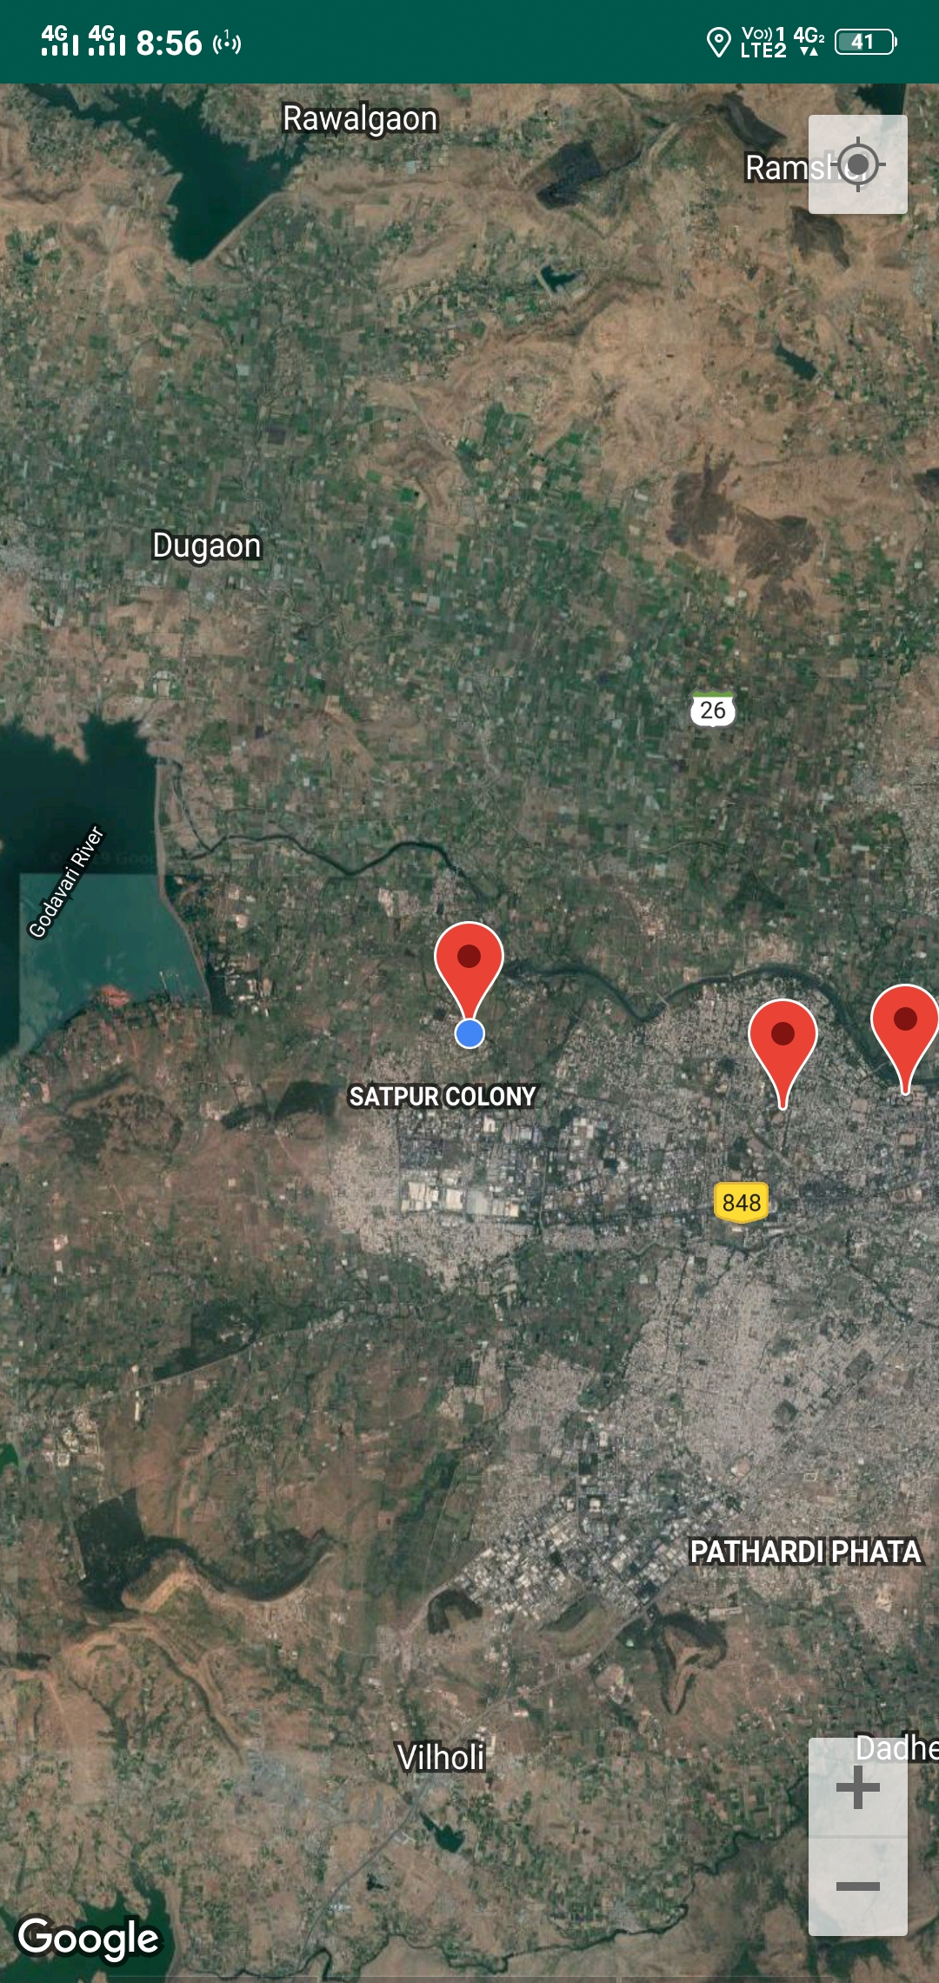

**Sensors and Microcontroller**

1. **Arduino Mirco-controller**

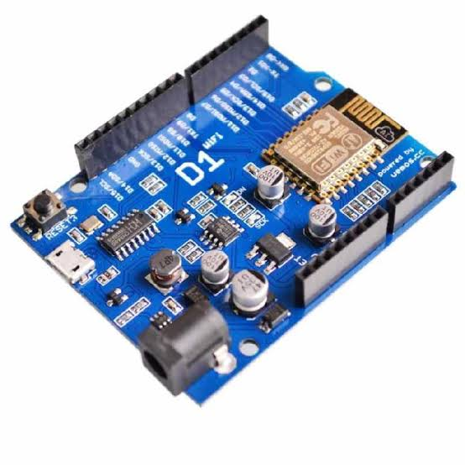

1. **Light Dependent Resistor**

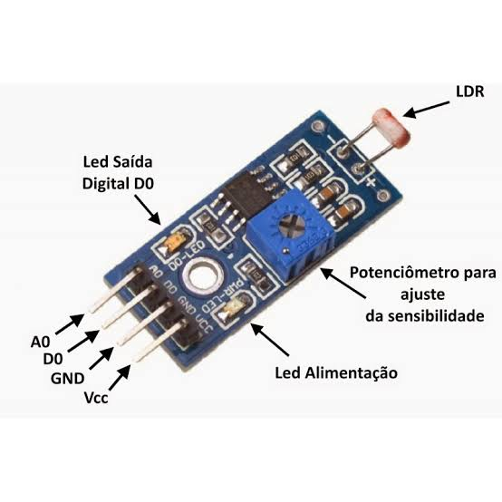

1. **Soil Moisture Sensor**

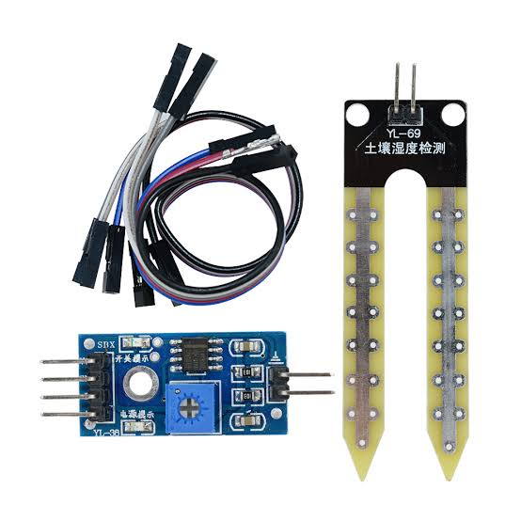

1. **Ultrasonic Sensor**

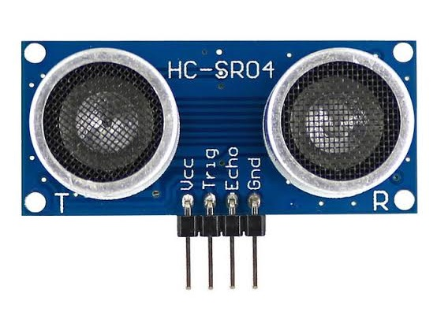

**Circuit Configurations :**

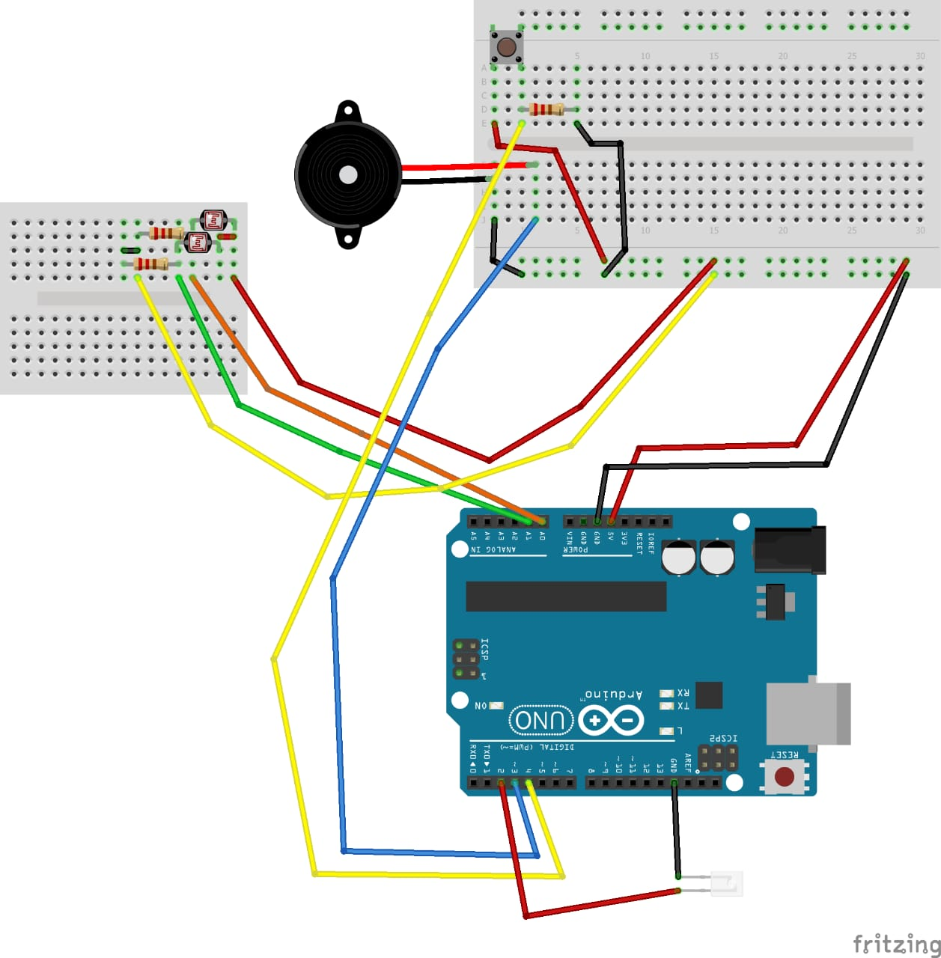 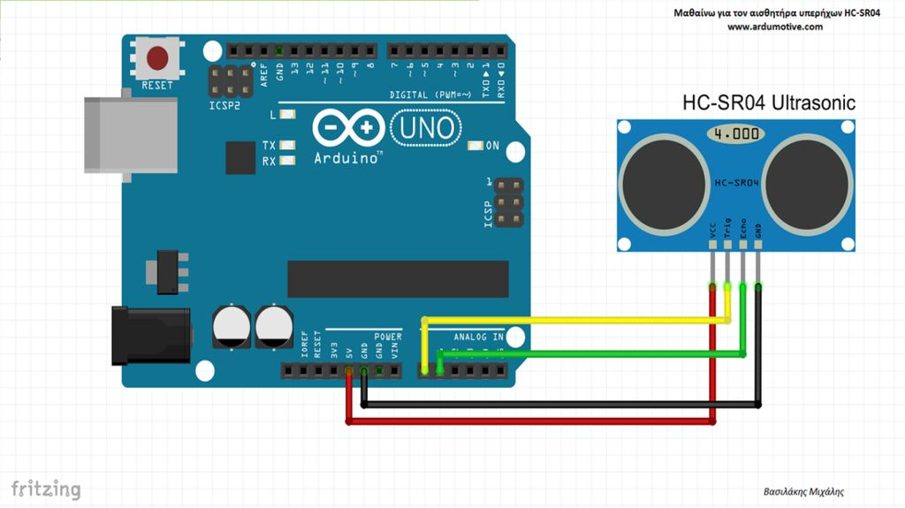

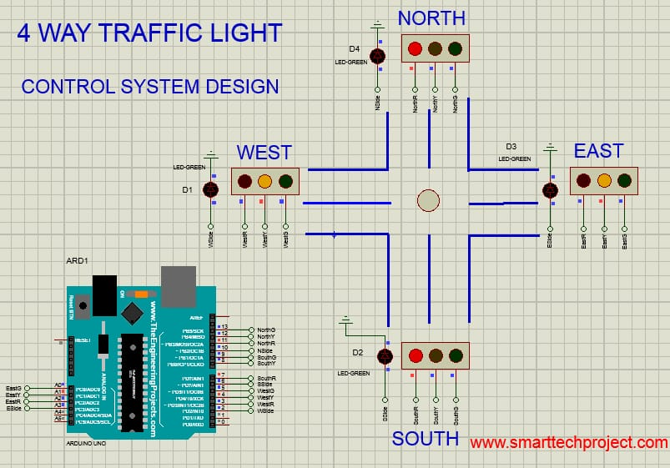

**CONCLUSION**

Throughout our endeavour of completion of our project we can say that we were quite fortunate to have the necessary support and guidance from our teachers and team members. It was only through such collective efforts that we were able to finish our project within ample time. It was a great learning experience for us to have built the ‘Smart City Project’.

We were able to successfully build a very comprehensible model of a Smart City. As mentioned earlier our Smart City project models most salient features of the Smart city. Our System is both flexible and scalable.

Users/Citizens can avail various services like Smart Parking and avoid the hassles of parking problems. There are also other services that will make the lives of the citizens more comfortable.

Admin can monitor various subsystems of the Smart City and in case of an anomaly or an event that violates rules for e.g If a citizen parks in no parking zone, the system will first warn the person and if warning is not paid attention to, it sends a message to the authorities to take necessary actions.

* BIBLIOGRAPHY: -
* For electronic components: -
* Links: -
* <https://www.arduino.cc/>
* <https://www.hackster.io/arduino/>
* <https://maker.pro/arduino/>
* PDF: -
* Arduino programming notebook
* Programming with Arduino by CentroPiaggio
* For website: -
* Links: -
* <https://codecourse.com/library>
* <https://stoneriverelearning.com/courses>
* PDF: -
* Learning PHP, MySQL & JavaScript: With CSS
* For app: -
* Links: -
* <https://developer.android.com/studio>
* <https://www.udemy.com>
* PDF: -
* Android programming cookbook